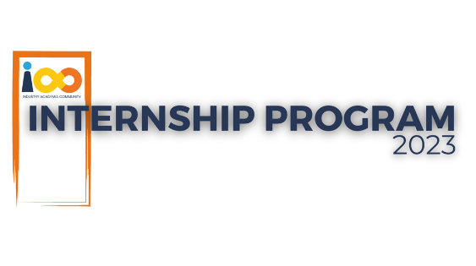

**PROJECT CHARTER**

|  |  |
| --- | --- |
| **GENERAL PROJECT INFORMATION** | |
| PROJECT NAME | SmartSolveAi Unified ChatBot |
| PROJECT SPONSOR | Tushar Topale |
| PROJECT MANAGER | Harshada Topale |
| EXPECTED START DATE | 07-08-2023 |
| EXPECTED COMPLETION DATE | 29-10-2023 |
| ESTIMATED COST | NA |
| **GOALS, OBJECTIVES, DELIVERABLES** | |
| PROJECT OBJECTIVE | The objective is to build a unified chatbot that is linked to various chat platforms where users can communicate to Cloud Counslage Pvt Ltd and Gift a Career Foundation for our Industry Academia Community Program |
| BUSINESS CASE | To help students to solve queries which need to be answered almost instantly. |
| GOALS/METRICS | The main aim is to create a speech driven chatbot along with text chat . |
| EXPECTED DELIVERABLES | Bot demo video in mp4 format , code in zip format with github link and project documentation |
| **PROJECT SCOPE AND SCHEDULE** | |
| WITHIN SCOPE | A functional MVP (Minimum viable product) bot connected with whatsapp SMS , using open source softwares/services |
| OUTSIDE OF SCOPE | To host project on paid services |
| **PROJECT RESOURCES AND COSTS** | |
| PROJECT TEAM | Subodh Kamble |
| SUPPORTED RESOURCES | VS Code , Twilio API ,python libraries, Rasa framework |
| COST ALLOCATION | NA |
| **PROJECT STAKEHOLDERS AND CUSTOMERS** | |
| PROCESS OWNER | Harshada Topale |
| KEY STAKEHOLDERS | Harshada Topale |
| END CUSTOMERS | Cloud Counselage Pvt. Ltd. |
| **PROJECT RISKS, CONSTRAINTS, ASSUMPTIONS** | |
| RISKS | If number of API calls gets above certain number it will not able to send messages in trial version of API ,if generative AI used it can sometimes hallucinate and lead to miscommunicate |
| CONSTRAINTS | Cannot use paid services to develop bot |
| ASSUMPTIONS | user should know that answers is generated by bot and not assume it as final answer, technical people should check efficiency of bot before deploy it into production |
| **MILESTONES** | |
| MILESTONE 1-REQUIREMENT GATHERING | 12/08/2023 |
| MILESTONE 2-PLANNING | 16/08/2023 |
| MILESTONE 3-DESIGN | 20/08/2023 |
| MILESTONE 4-DEVELOPMENT | 20/09/2023 |
| MILESTONE 5-TESTING | 24/09/2023 |
| MILESTONE 6-DEPLOYMENT | 27/09/2023 |
| MILESTONE 7-CLOSURE | 29/09/2023 |